SAMPLE Kodu Research Design Document

Research
In this section, students will select a question or concept related to the project and use the internet or other sources to search for information and solutions. Students may investigate their own question or choose one from the list below:
Sample Questions
- What are the benefits of playing video games? What are the risks?
- What is the process to become a video game designer?
- Do violent video games make people violent?

Sources
Cite the sources where you got your information from in order to answer the questions.

Specifications
Bird’s Eye View of World

Side View of World
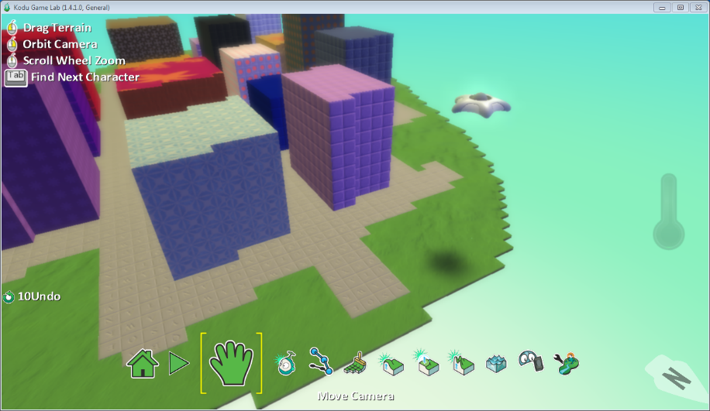

Main Character Code

Explain what each line of code does. (Example: Line 1 makes Kodu move with the keys WASD; Line 2 changes Kodu’s view to 1st person)

Enemies Code

Explain what each line of code does. (Example: Line 1 makes the enemy move around slowly, Line 2 makes it so that when the enemy sees Kodu, he shoots missiles at him)

Other Code
Explain what each line of code does.

Conclusion
In the last section, students will write a conclusion which summarizes the modifications to their final game. Include any changes that was made from the original idea, such as adding characters, features, etc.

