How to Add Animation to a PowerPoint
1. Animate EVERYTHING. EVERY Picture, EVERY Line of Text
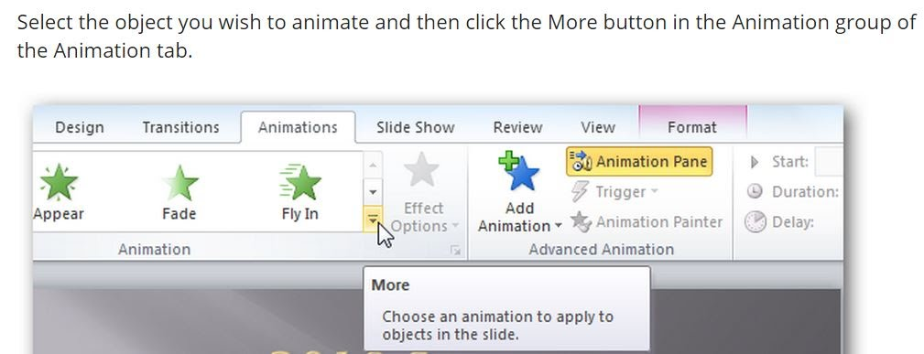
2. Check out all the buttons in the Animation Tab of PowerPoint

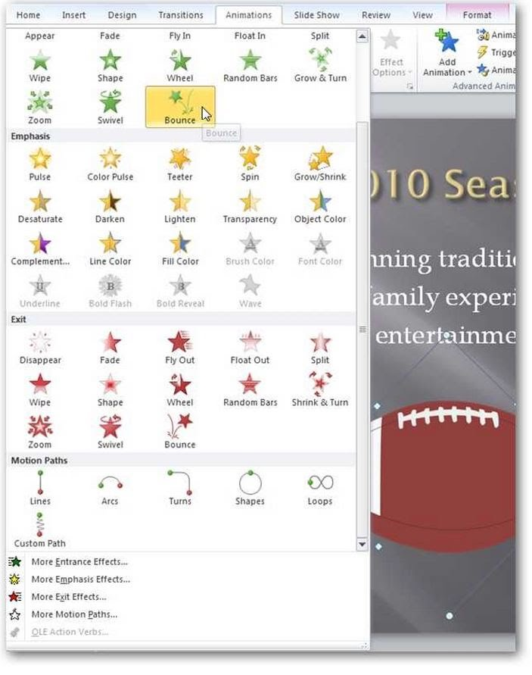
Check out all the cool animations you can do! With text, use both appear and disappear options.

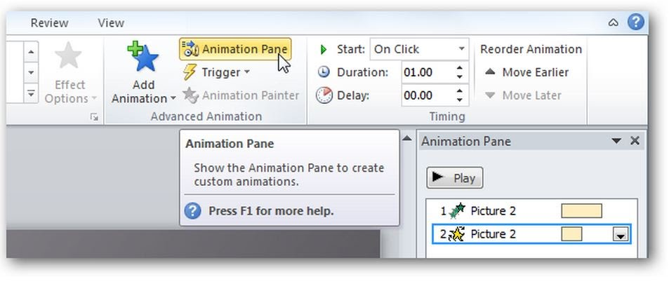
3. Click on Animation Pane to get a window next to your powerpoint that allows you to mess with your animations

4. Use More _______________ effects to be able to customize how each works.
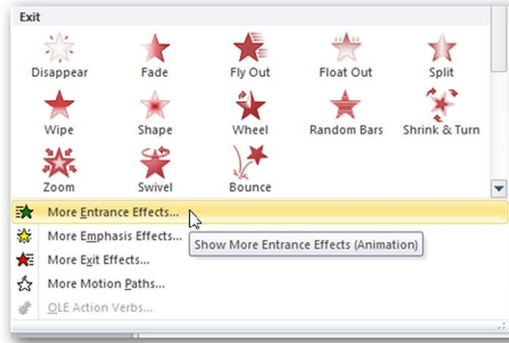

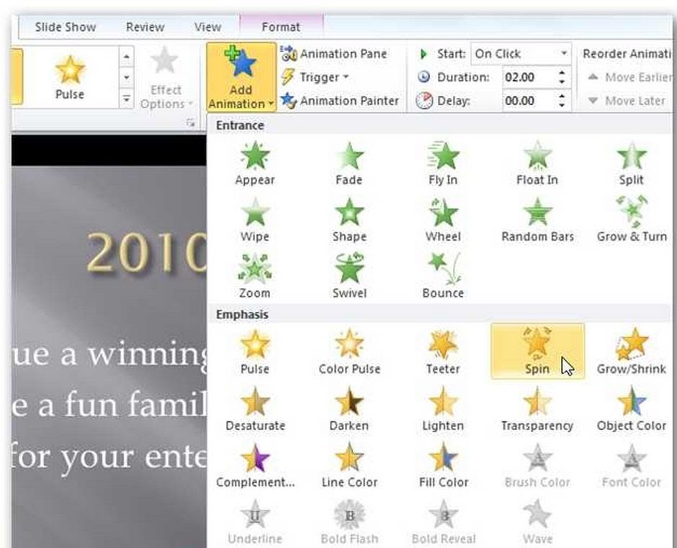
5. You can add several animations to any object. For example, you can make an object fly in, and then spin in a circle.

BUT THEN YOU CAN DO SOOOO MUCH MORE!!
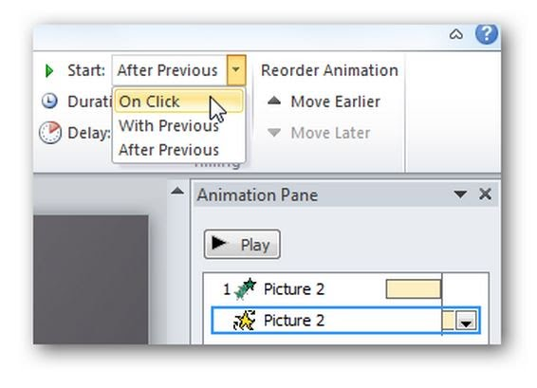
6. When you add multiple animations, you need to say when you want each one to happen. For this PowerPoint you need to use: With Previous OR After Previous. DO NOT USE ON CLICK.

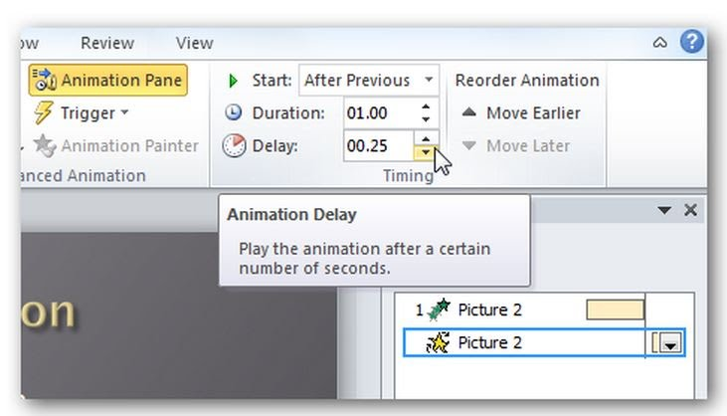
7. Next, you can then add how soon you want it to occur.

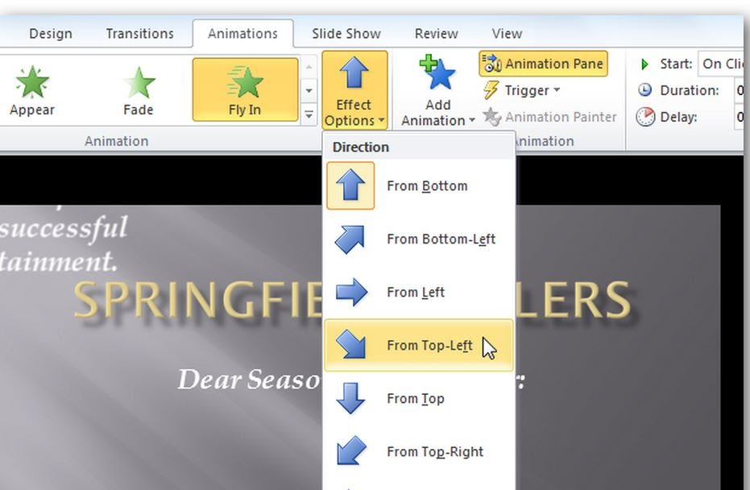
8. Each animation has extra effect options that can let you customize it EVEN MORE.

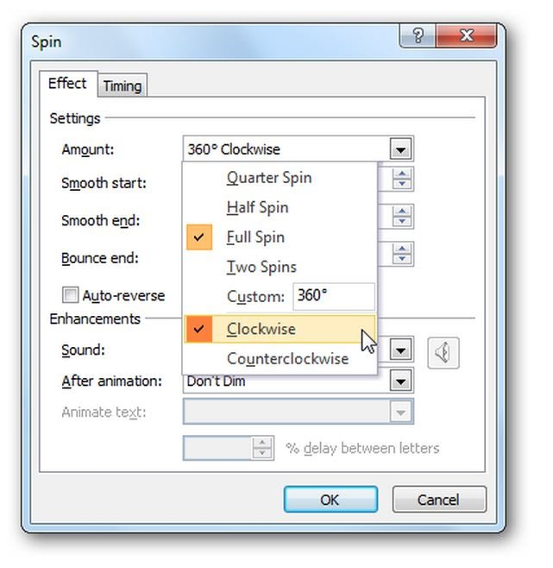
For example, you can choose how much spin and what direction

