SAMPLE 3D Derby Design Document:
Research:
In this section students will answer a research question related to their project. They will be scored on the relevance of their question, how well they answer the question and cite their sources. (3 or more reliable sources)
Sample Questions:
How does mass affect a car’s speed down a ramp?
What role does friction play in a car’s tires?
Do large or small tires make a car go faster?
What does a spoiler do on a car?
Specifications:
Side View of Car: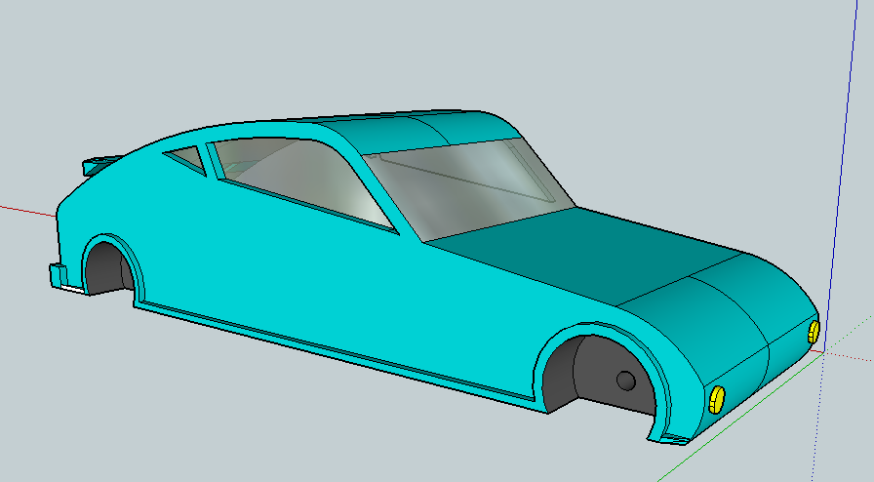
Car Dimensions: Wheel Opening Dimensions:
Length: 125.5mm Diameter: 14.5mm
Width: 43mm Depth: 7.4mm
Height: 33.2mm
Front View: Rear View:
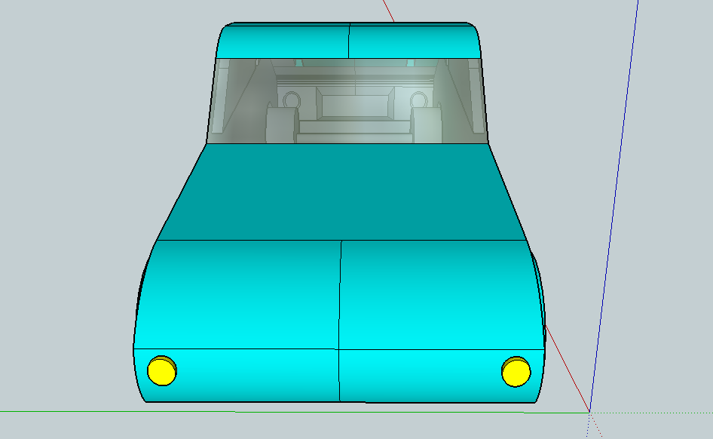
Wheel Dimensions:
Diameter of Wheel: 13.1mm
Thickness of Wheel: 6.2mm
Diameter of center hole: 2.1mm

Testing:
Students will explain the testing of their car and what modifications they made to improve its speed. This could include physical changes to the car such as smoothing/sanding the body or wheels, adding a spoiler or anything else. It should also include testing of different lubricants on the axels. Students should include a data table showing the results of different trials.
Trial | Time | Adjustments
1 | 10.2 s | None, just attached the wheels to the car body.
2 | 9.7 s | Smoothed the axel hole of the wheels and smoothed the outer edges of the wheel.
3 | 7.2 s | Used lubricant A on the axels.
4 | 8.4 s | Used lubricant B on the axels.
5 | 7.7 s | Used lubricant C on the axels.
6 | 7.0 s | Added a spoiler to the back of the car.
Conclusion:
We decided to use lubricant A because it gave us the fastest time in our testing. We also smoothed out both the inner and outer edges of our wheels to increase speed. Then we added a spoiler to increase the mass of our car closer to the maximum mass allowed.

