Team Members Names: ________________________
Instructions: Fill out this document as you go through your design process. REPLACE the instructions of each section with YOUR WORK as you go
Bridge Design Document
Research:
In this section students will answer a research question related to their project. They will be scored on the relevance of their question, how well they answer the question and cite their sources. (3 or more reliable sources)
Sample Questions:
What are the benefits/limitations of different bridge structures?
What roles do compression and tension play in a bridge structure?
What makes a good bridge?
Format
1. Introduction Sentence
2. Answer to the three questions
3. How it relates to your project
4. List Sources
Specifications:
Drawing Board View of Bridge (from West Point Bridge Design):
(Insert Screen Shot from West Point Bridge Designer)

3D Model of Bridge (from Sketchup):
(Insert screenshot from Sketchup!)

Picture of actual Bridge:
(Take a picture of your bridge after it has been 3-D printed)
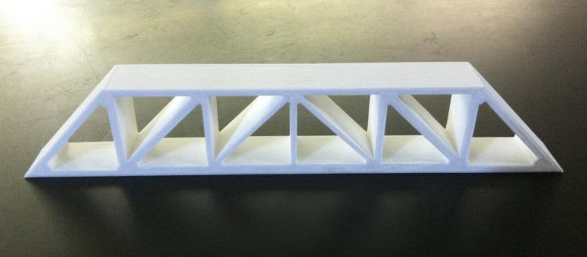
Bridge Dimensions:
Length: 212mm
Width: 22mm
Height: 38mm
Testing:
Virtual Testing:
Students will explain how they designed and tested their bridge in the West Point Bridge Design program and what modifications they made to improve its structural efficiency. This could include minor adjustments such as increasing/decreasing the size of individual components; or major changes such as complete redesign or use of a completely different structure.
Picture of Load Test in WPBD:
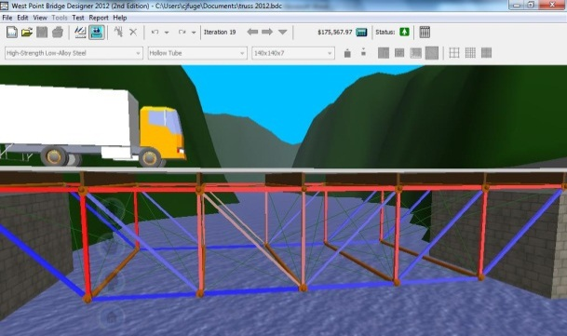
Physical Testing:
Students will describe what modifications they made after testing their bridge past its breaking point. They should include a picture of the broken bridge and explain what changes were made to increase strength and prevent repeated failure.
Picture of Broken Bridge:
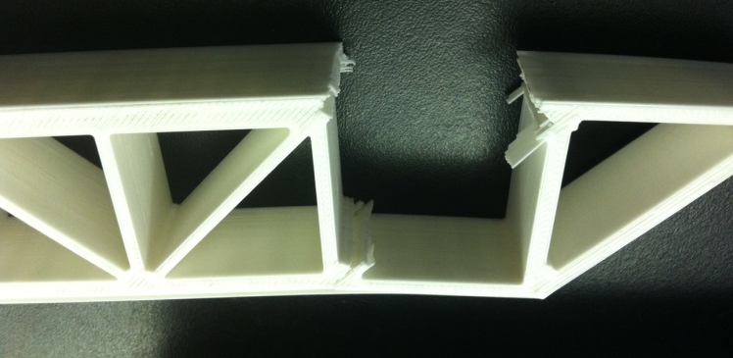
Conclusion:
We decided to… We also … to increase structural efficiency. Then we … to increase the strength of pieces 4 and 16 so they didn’t break again. From our research we learned that …

